**Management Plan - Pingr**



Hunter Davis

Oscar Gepiga

Tymee Kong

Tanner Mindrum

Shihong Sun

CECS 491A

Jean Tsao

2/17/2020

**Gantt Chart**

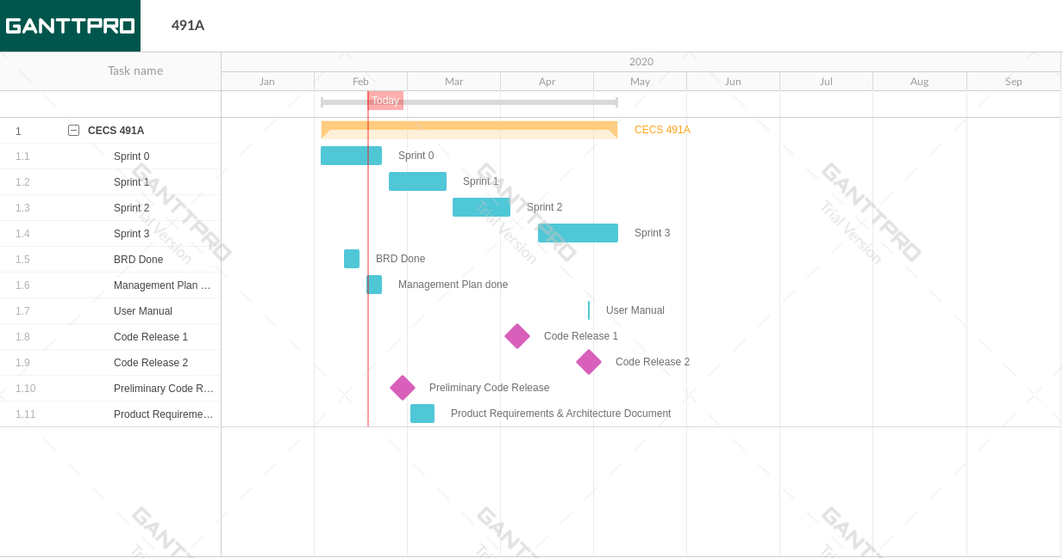

**Project tracking matrix**

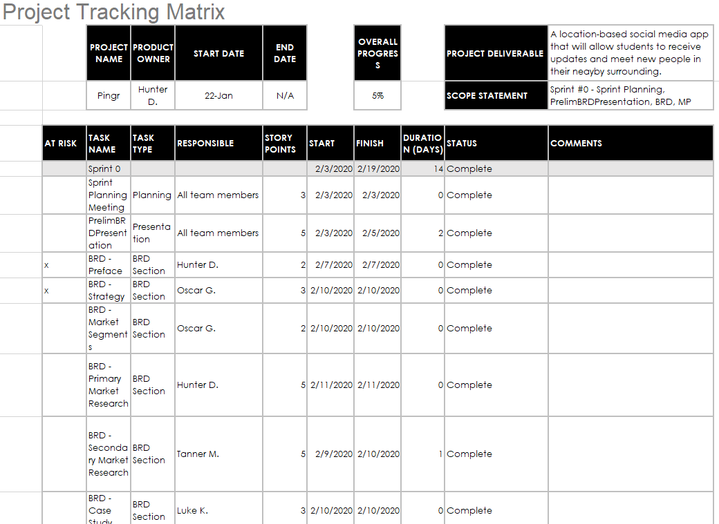

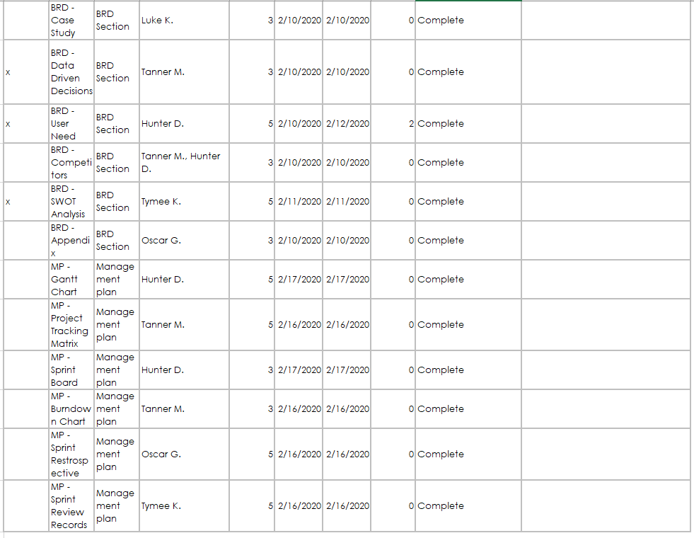

**Sprint board 0 (Before)**

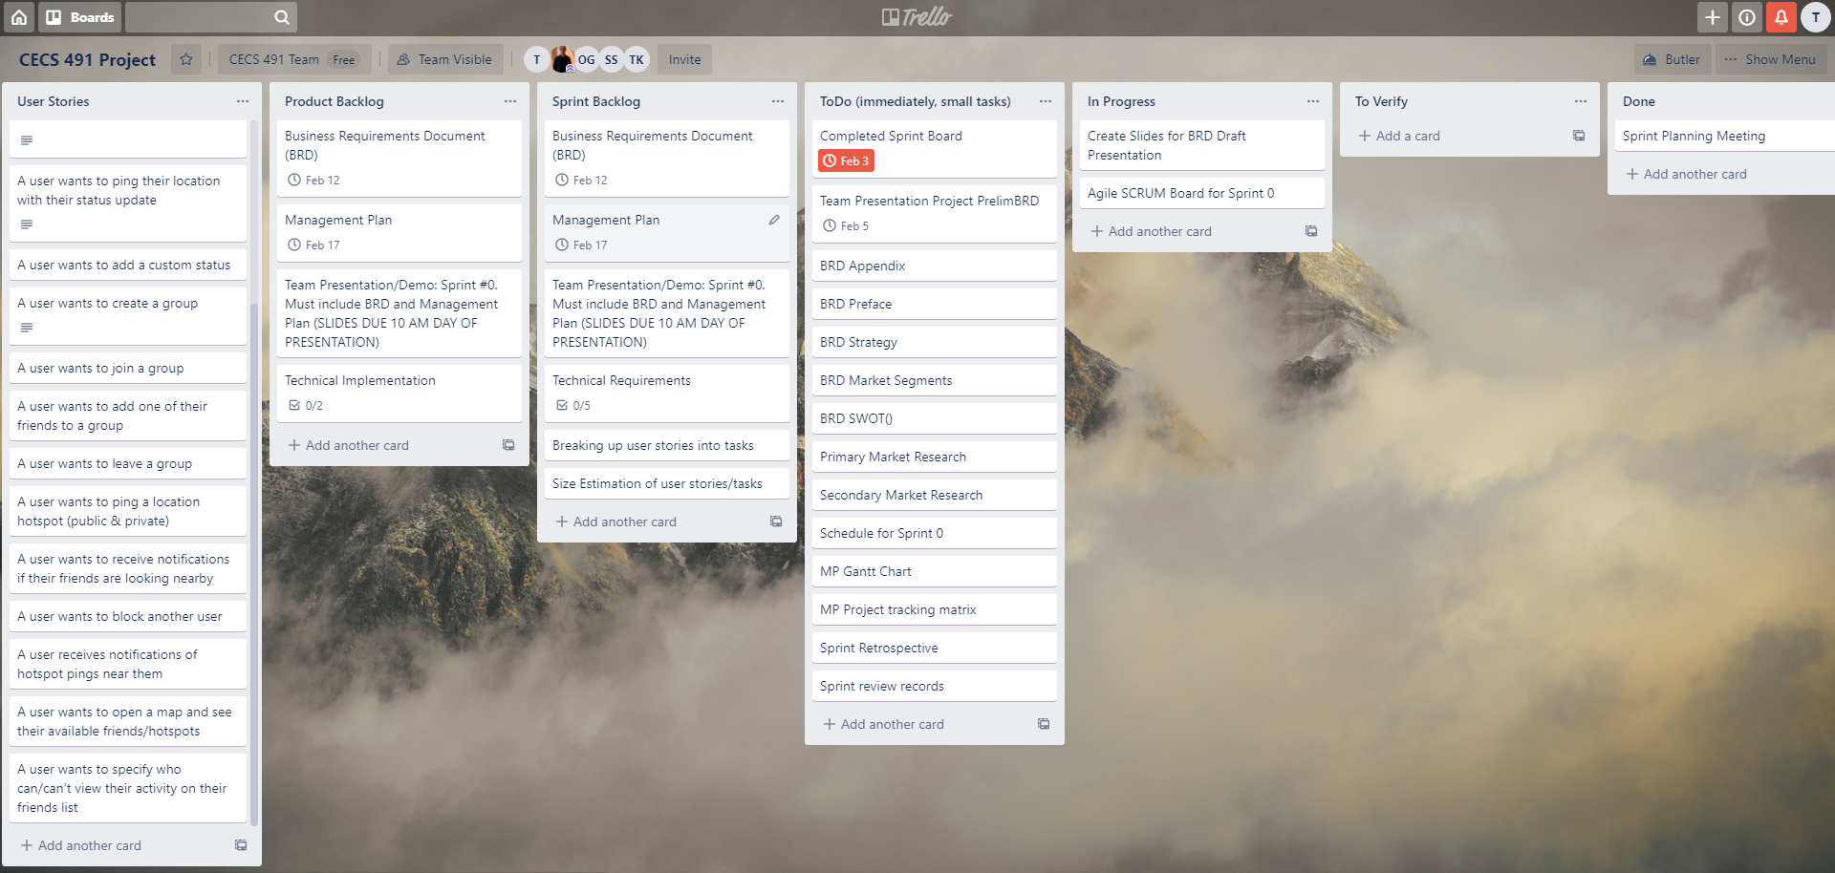

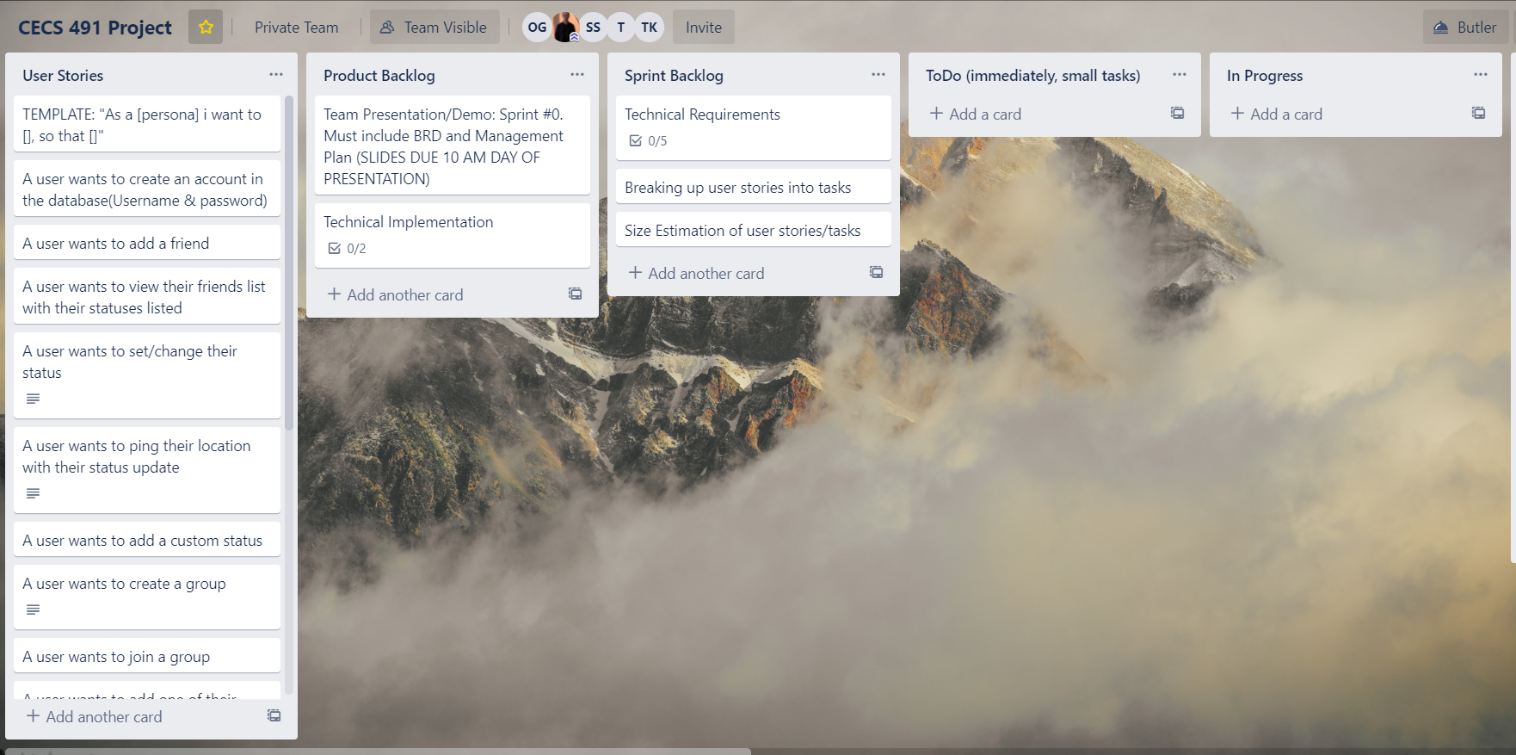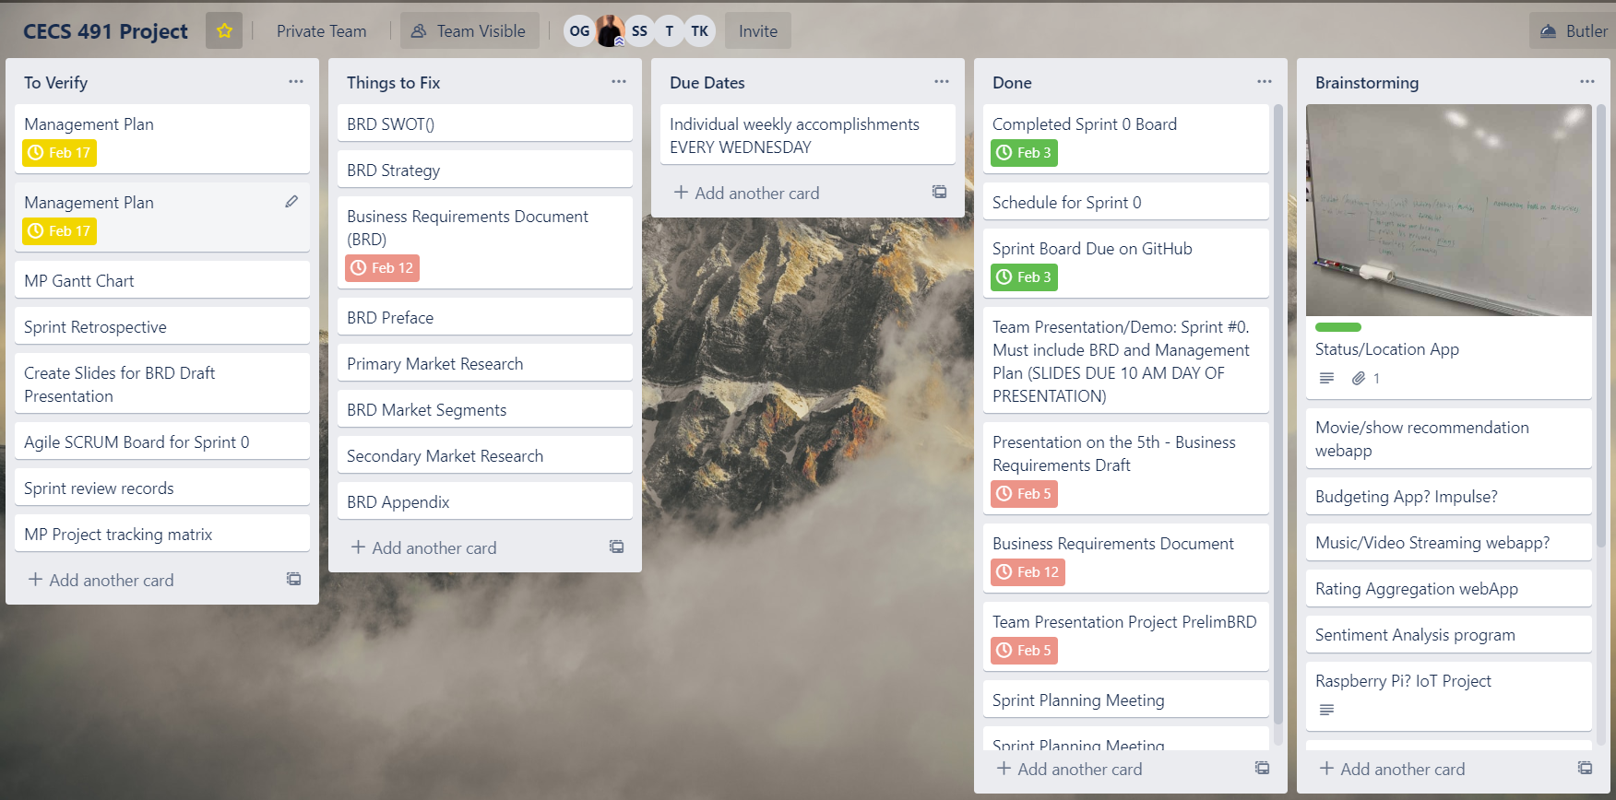

**One burndown chart per sprint**

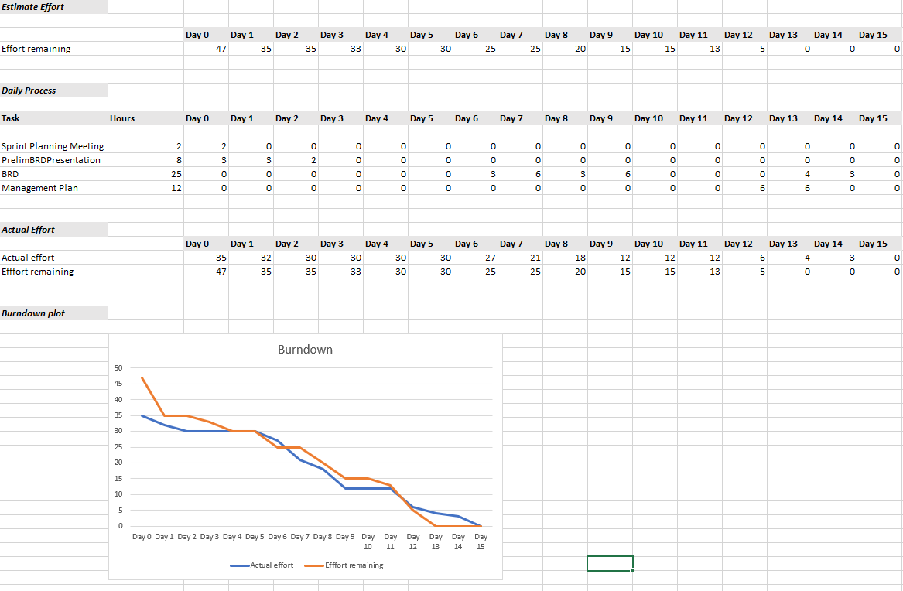

**Sprint 0 Retrospective**

In retrospect a lot needs to change. It is obvious now that our idea has no clear direction. Our team morale is low. Our idea either needs to be sharpened or replaced completely. The Business Requirements Document was completed and returned promptly with various critiques. We wish to fix and change the BRD for the next sprint as well as work on the project requirements document and the architecture and design document with no hiccups. Our BRD is a wake-up call to us that more time needs to be put into this project. During this sprint it was also clear that we worked more as individuals rather than a collective unit. More time needs to be set in place for meetings outside of class/lab as well as proper delegation of work amongst the group.

**Sprint review records - Appendix**

During sprint 0 we had to come up with an idea for our rehearsal presentation. Our team had a long discussion where we were throwing out ideas and what we were interested in. We had an idea that was not too fleshed out by the time we presented but we had a foundation of what we wanted to do for our project. We were hoping that we could flesh out our idea but due to a lack of meetings outside of class/lab, the idea stagnated and many of us were confused about the direction of our app.

The whole Business Requirement Document except for the competitors segment is not finished. This is because after examination we did not receive the grade we wish to have in the other segments. It seemed that in our document the only thing that was clear was our competitors. Our app’s unclear direction is a reflection to our lackluster BRD. The direction of our app is unclear as of right now which will need to be fleshed out as soon as possible. As of right now our management plan is “done” for the sake of turning in but, due to the nature of the management plan will continually evolve throughout our time on this project.